Homework # 2

Ruchi Panwar (rpanwar@kent.edu)

Advance Database

Fall 2015

Professor: Dr. Gregory S DeLozier

Oct 6, 2015

**1**. Get Python set up on your computer.

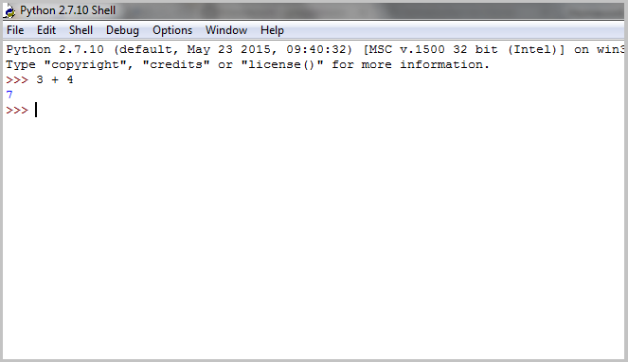

**2**. Get your PythonAnywhere account set up.

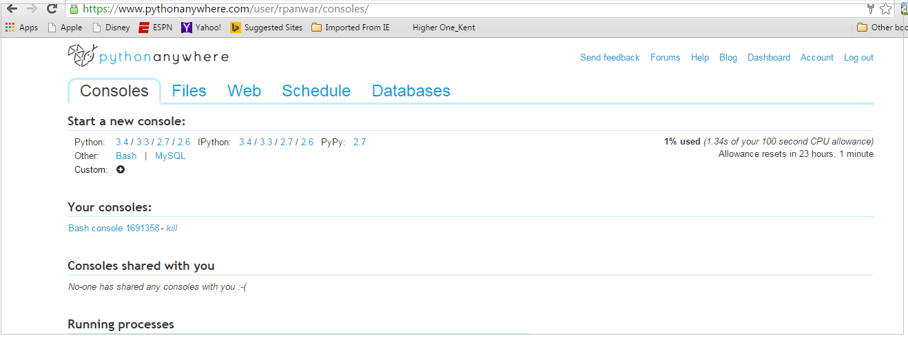

PythonAnywhere Link - <https://www.pythonanywhere.com/user/rpanwar/consoles/>

**3**. Get Visual studio code setup on your system.

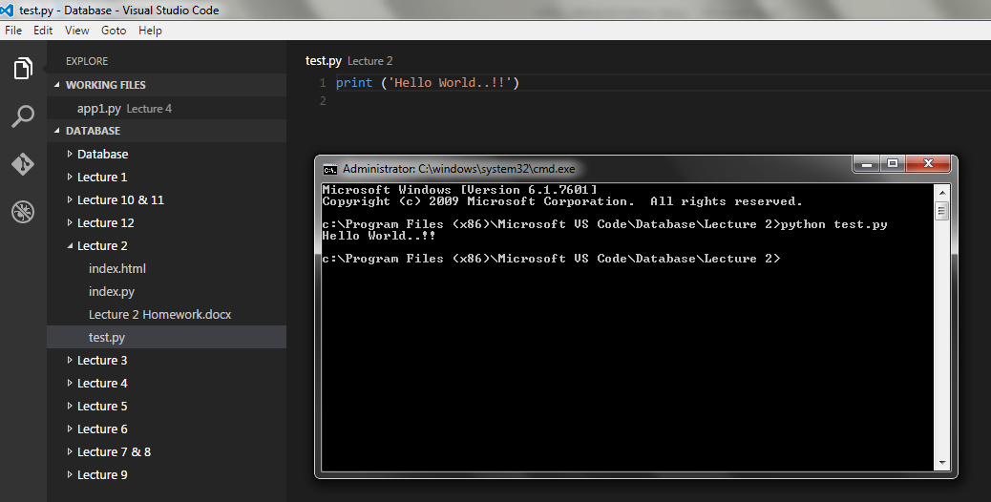

**4**. Get your Github account setup for ADB.

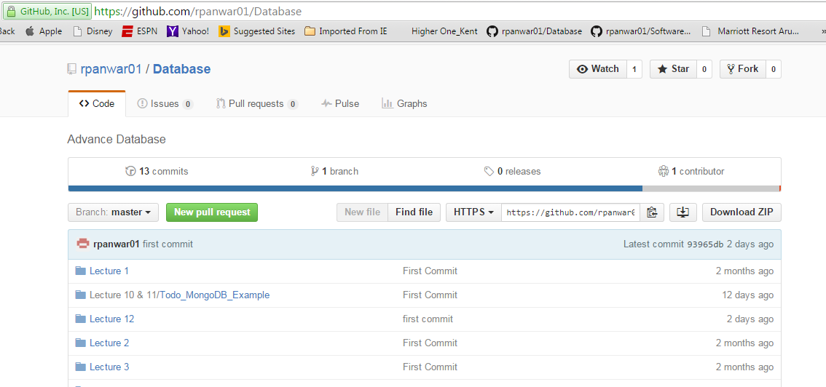

Github Link - <https://github.com/rpanwar01/Database>